

**Power BI Custom Connector using OAuth2 Service**

|  |  |
| --- | --- |
| **Project Name**.: Custom Power BI Connector using OAuth2 Service  **Version**: 1.0.0  **Start** - **Target Date**: 02/23/2022 - 02/29/2022  **Author**: Amit Timalsina | ****Prepared by with date:** 02/25/2022**  ****Approved by with date:**** _________________ |

**Introduction**

Data Connectors for Power BI enables users to connect to and access data from your application, service, or data source, providing them with rich business intelligence and robust analytics over multiple data sources. With Custom data connector, we build our own connection provider for **External Accounting Power Core API using OAuth2 Authentication**. Data Connector Project in Visual studio facilitates creating .mez file which will appear in the list of Get Data in Power BI similar to other connectors.

**Data Connector Project Setup**

1. Download and install **Power Query SDK** from Visual Studio Marketplace (SDK only supports VS 2019 and before).
2. Create a Power BI Connector Project on VS 2019
3. Define your connector Logic
4. Setup OAuth2 Validation and consume rest API.
5. Create .mez extension file
6. [Click here Learn More](https://github.com/amittyyy/PowerBI_CustomConnector)

**Setup Custom Data Connector on Power BI Desktop**

1. Copy the extension file (.**mez**) into the [Documents]\Power BI Desktop\Custom Connectors directory
2. Open Power BI Desktop
3. Go to File | Options and settings | Options
4. Lower the Security level for extension in Power BI Desktop to enable loading uncertified connectors.
5. For Oauth2 login, check Use my default web browser**.**

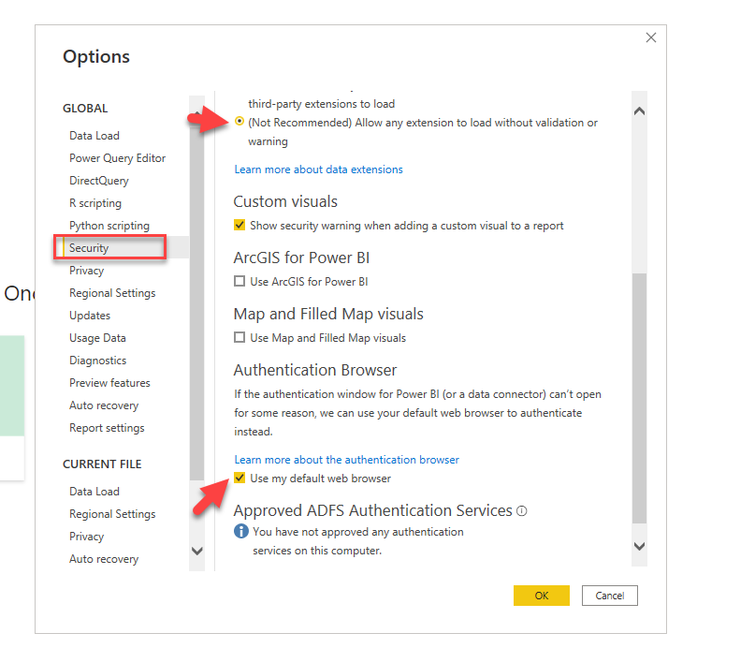

1. Restart Power BI Desktop
2. Click Get Data option | More | Other | Find AccountantsWorldConnector Beta
3. Select connect

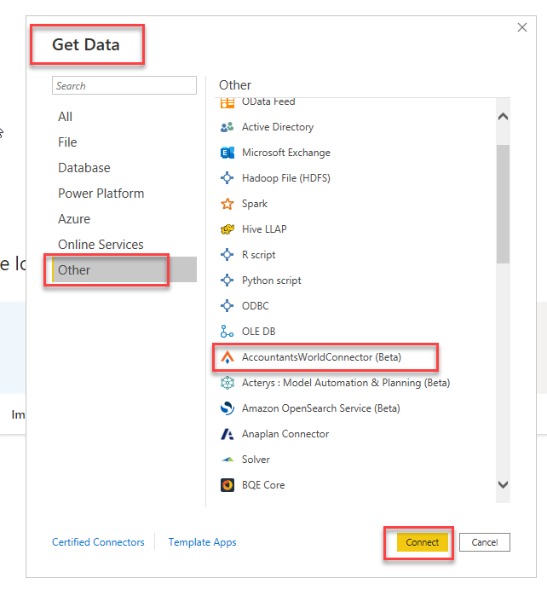

1. Implement an OAuth v2 authentication flow and login using your staff Login

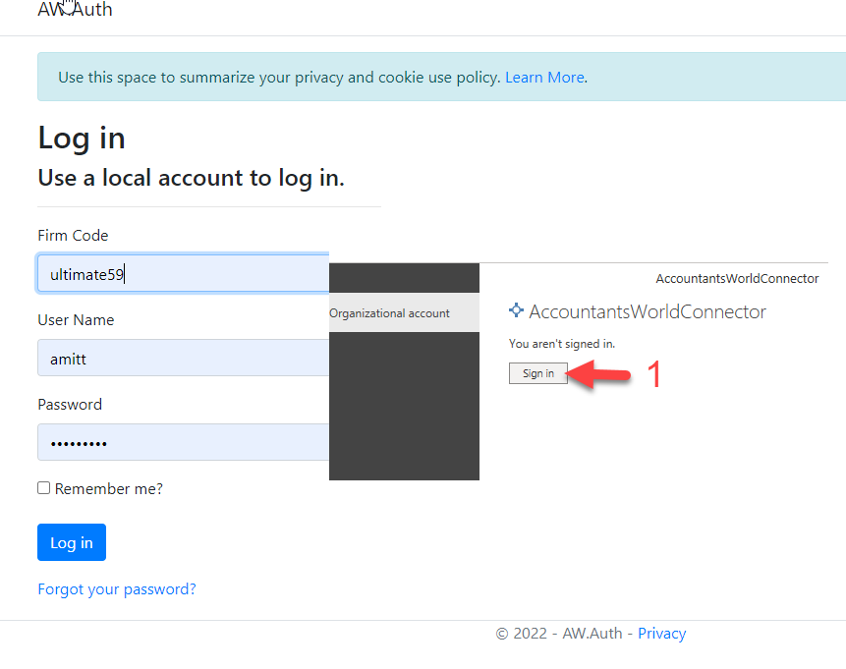

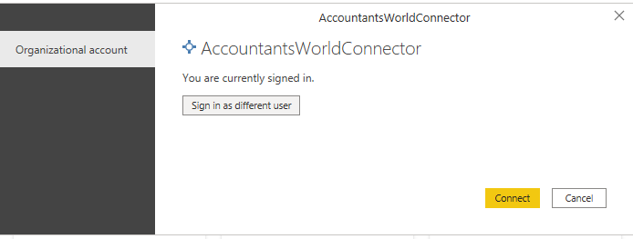

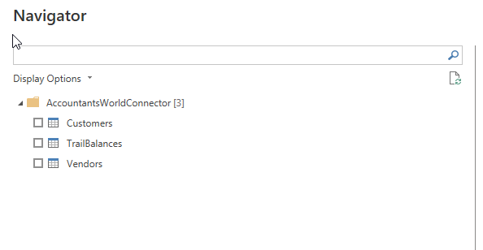

1. Completed

**References**

- h*ttps://docs.microsoft.com/en-us/power-query/installingsdk*

*- https://jussiroine.com/2019/02/building-a-custom-connector-for-power-bi-that-supports-oauth2-to-visualize-my-wellness-data/*

*- https://jussiroine.com/2019/02/building-a-custom-connector-for-power-bi-that-supports-oauth2-to-visualize-my-wellness-data/*

*- https://docs.microsoft.com/en-us/power-query/samples/github/readme*

*- https://radacad.com/power-bi-custom-connector-connect-to-any-data-sources-hello-world#:~:text=Power%20BI%20recently%20introduced%20a,BI%2C%20similar%20to%20other%20connectors.*